
VILNIUS GEDIMINas Technical university
Faculty of Electronics
department of Electronics systems

Machine Learning
Laboratory work 7
Authors: Kirill Postrehan, EDIfu 24/1
Lecturer: Dr. Olusola Oluwakemi Abayomi Alli

VILNIUS 2026
Introduction:
In this laboratory work, I used cyberbullying classification dataset and applied two models to predict whether the message contains offence.
Task:
In this laboratory work I need to preprocess data and make sure that it is balanced. Fine-tune models using grid and random search cross validation techniques to find the best model parameters and mitigate potential data leakage ensuring that information from the test set does not influence the training or validation phases. And finally evaluate models using perfomance evaluation metrics, such as precision, recall, F1-score, ROC-AUC, PR-AUC and confusion matrix to see how model performs and how well predicts specifix classes.

Logistic Regression
The first model I used was LogisticRegression. Grid Search cross-validation 5 folds returned that the best max_iter for LogisticRegression where it is equal to 1000
During evaluation of the best model, I made a classification report:
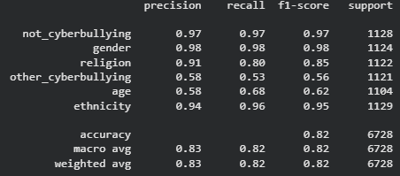
We see that the model struggles to predict correctly cyberbullying based on age and other types. Such low recall indicated that model mises amny true positives and low precision that a lot of false positives in predictions.
Then I ploted the confusion matrix to see how many times the model predict well specific classes:
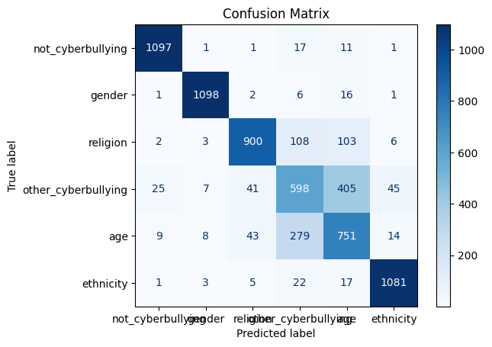
So the confusion matrix clearly shows us where the model struggles a lot, that proves the point about the classification report table.
Then I made ROC-AUC and PR-AUC curves:

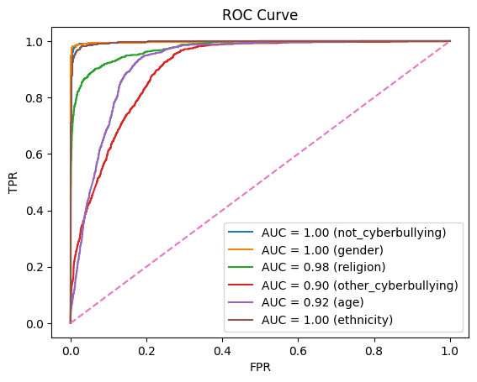
The ROC AUC curve shows a good result, however we should not depend on it a lot because does not measure classification errors. The model may know which samples are likely positive but may misclassify at the chosen threshold.

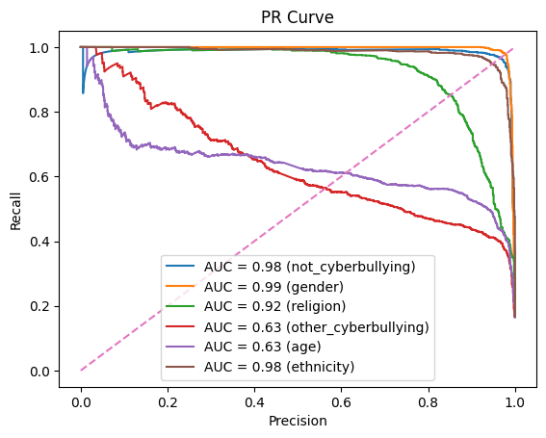
PR curve shows better what classes are actually weak and it is because it focuses on precision and recall, which directly reflect real classification performance. The age and other cyberbullying classes showed substantially lower PR-AUC scores (0.63 and 0.63), indicating poor precision and higher false positive rates.

XGBoost
Then I used XGBClassifier. Random Search cross-validation with 10 iterations and 5 folds returned that the best XGBClassifier model is the one with 100 n_estimators, 7 max_depth and 0.1 learning_rate.
During evaluation of the best model, I made a classification report:
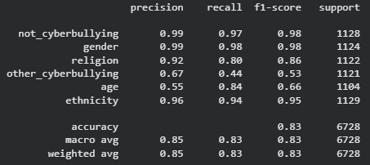
In comparison to the logistic regression, XGBClassifier's metrics on age show an improvement in recall and f1 score, however when it comes to other types of cyberbullying both recall and f1-score show worse performance while only precision shows increase.
Then I plotted confusion matrix:
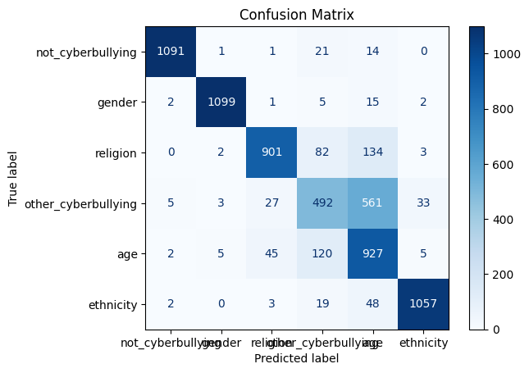
This confusion matrix shows that XGBClassifier is indeed better at correctly classifying age, but struggles even more on other_cyberbullying.
Then I made ROC-AUC and PR-AUC curves:
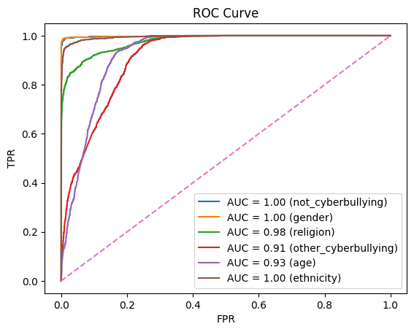
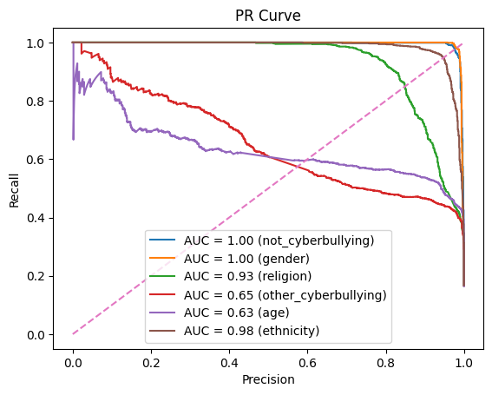
The situation is the same as on the previous PR AUC curve for logistic regression. The age and other cyberbullying classes showed substantially lower PR-AUC scores (0.63 and 0.65, respectively). PR AUC shows that the model have a great performance on every other classes.

Conclusion:
The models achieved strong performance on clear categories such as gender and ethnicity, with near-perfect ROC-AUC scores. However, it struggled with classes like age and other cyberbullying, as shown by lower PR-AUC values. Future improvements could include transformer-based models to better capture context.

